### 1.3. Mobile application for Shipper

#### 1.3.1. User Case Diagram

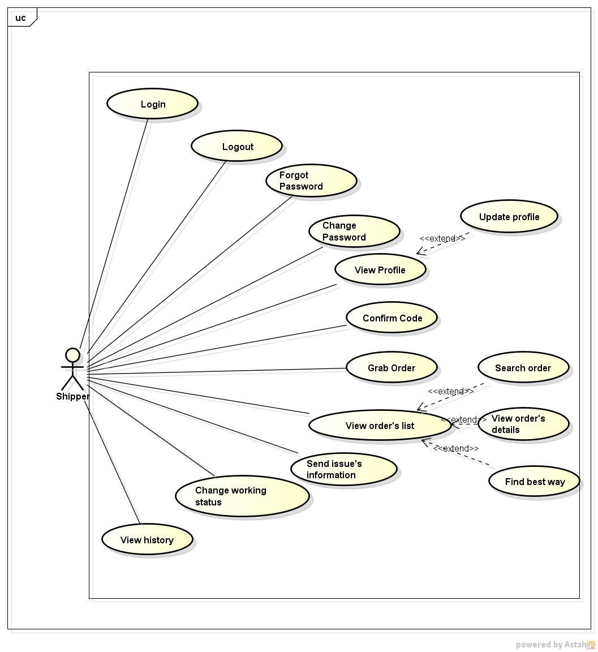

#### 1.3.2. Function

###### *UC-301:* *Login*

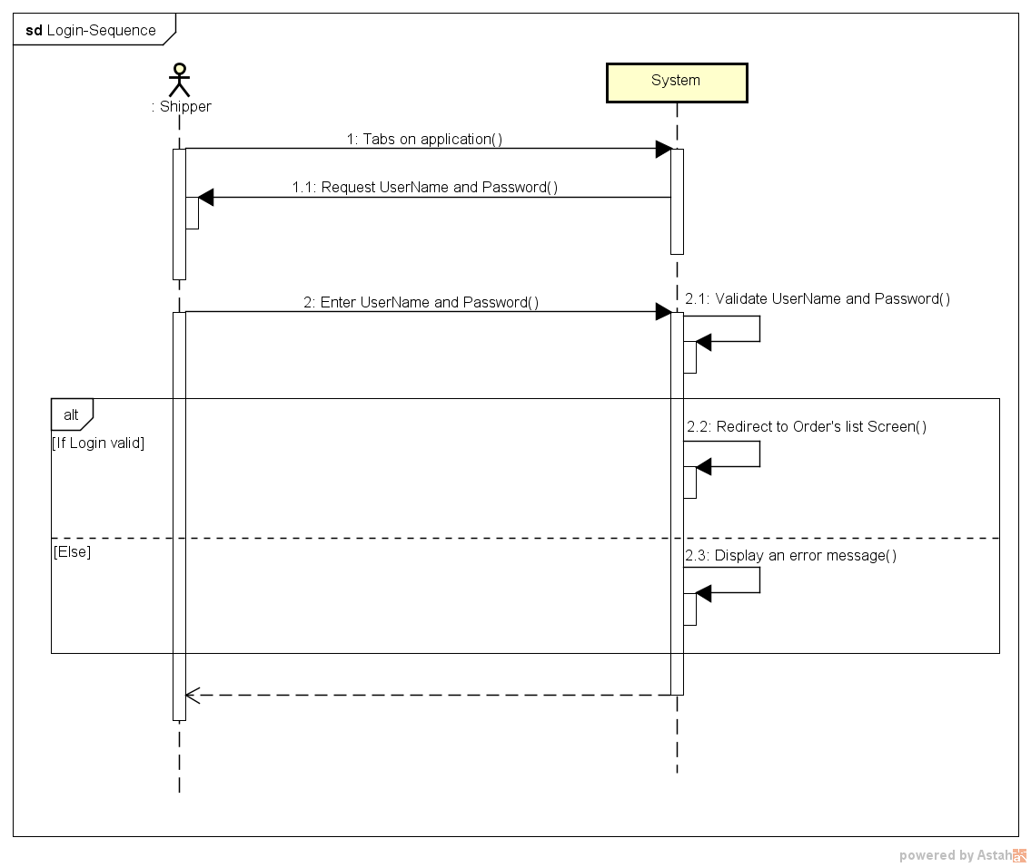

|  |  |  |  |  |
| --- | --- | --- | --- | --- |
| Use Case ID: | | UC-301 | | |
| Use Case Name: | | Login | | |
| Created By: | | QuyenNV | Last Updated By: | QuyenNV |
| Date Created: | | 19/09/2015 | Date Last Updated: | 24/09/2015 |
| Actor: | | Shipper | | |
| Description: | | Shipper provides his or her access credentials in order to use system. | | |
| Triggering event | | Shipper login to system. | | |
| Preconditions: | | Internet connection is established. | | |
| Post - conditions: | | The shipper’s session is stored. | | |
| Priority: | | High | | |
| Frequency of Use: | | Sometime | | |
| **Main flow** | | | | |
| Step | Actor | Action | | |
| 1 | Shipper | Tabs on application | | |
| 2 | System | Request the shipper input the following fields are available:  + username  + password | | |
| 3 | Shipper | Enter information (username and password). Shipper clicks on Log In. | | |
| 4 | System | Validate UserName and Password | | |
| 5 | System | Login successful into application. System grant access to system and redirect to Order’s list screen | | |
| **Alternative Flows:** | | N/A | | |
| **Exceptions:** | | | | |
| EC1 | At step 4, if account’s information is invalid | | | |
| Step | Actor | Action | | |
| 4.1 | System | Display an error message on [Login] screen | | |
| **Includes:** | | N/A | | |
| **Special Requirements:** | | N/A | | |
| **Notes and Issues:** | | N/A | | |

###### *UC-302:* *Logout*

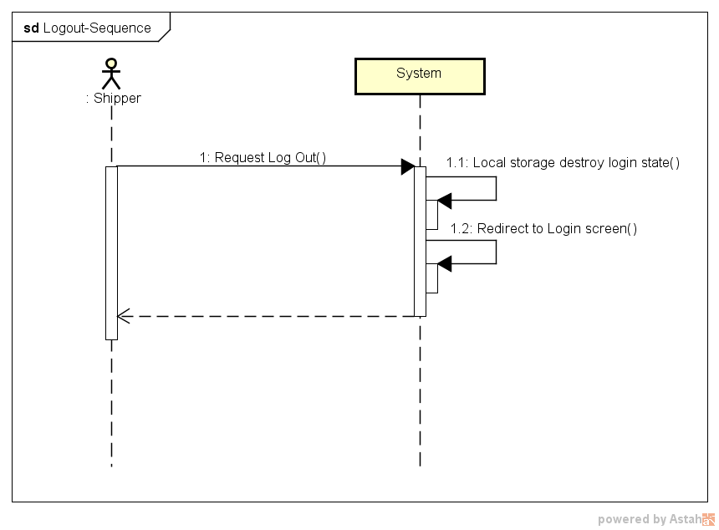

|  |  |  |  |  |
| --- | --- | --- | --- | --- |
| Use Case ID: | | UC-302 | | |
| Use Case Name: | | Logout | | |
| Created By: | | QuyenNV | Last Updated By: | QuyenNV |
| Date Created: | | 19/09/2015 | Date Last Updated: | 24/09/2015 |
| Actor: | | Shipper | | |
| Description: | | When shipper finish their work they will logout of the system. | | |
| Triggering event | | Shipper logout of the system. | | |
| Preconditions: | | * To be logged in the system * To have Internet connection through device | | |
| Post - conditions: | | * The connection to the server is terminated. | | |
| Priority: | | High | | |
| Frequency of Use: | | Sometime | | |
| **Main flow** | | | | |
| Step | Actor | Action | | |
|  | Shipper | Click “log out” button. | | |
|  | System | Terminates the connection. Local storage destroy login state. | | |
|  | System | Redirect to “Login” screen of application | | |
| **Alternative Flows:** | | N/A | | |
| **Exceptions:** | | N/A | | |
| **Includes:** | | N/A | | |
| **Special Requirements:** | | N/A | | |
| **Notes and Issues:** | | N/A | | |

###### *UC-303:* *Forgot password*

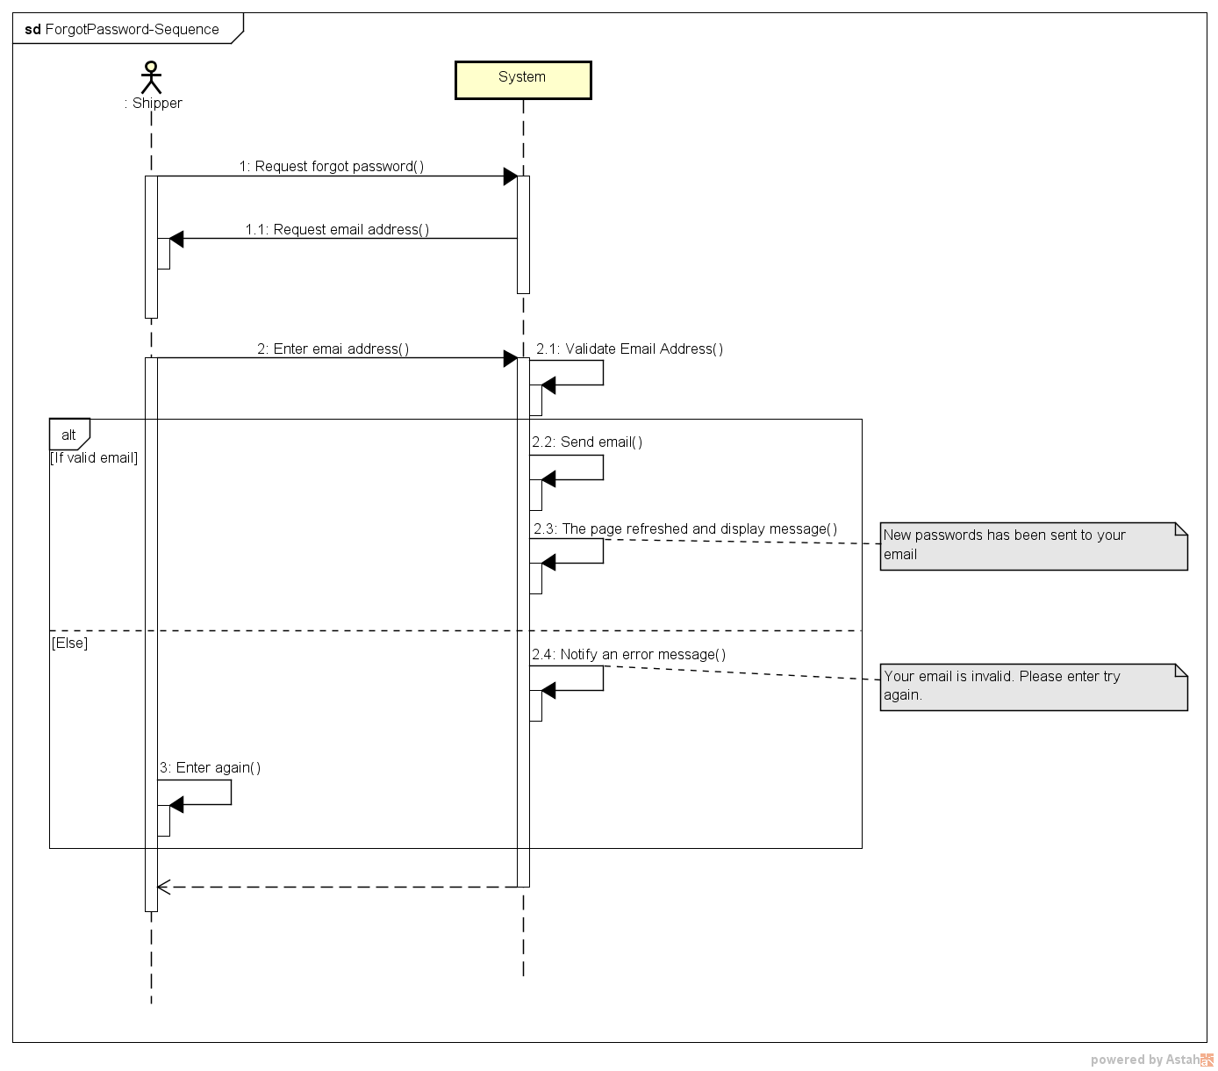

|  |  |  |  |  |
| --- | --- | --- | --- | --- |
| Use Case ID: | | UC-303 | | |
| Use Case Name: | | Forgot password | | |
| Created By: | | QuyenNV | Last Updated By: | QuyenNV |
| Date Created: | | 19/09/2015 | Date Last Updated: | 24/09/2015 |
| Actor: | | Shipper | | |
| Description: | | * When shipper forgot their password. Shipper wants reset their password. | | |
| Triggering event | | * Shipper forgot their password. | | |
| Preconditions: | | * To have internet connection through device. * Shipper haven’t logged in to the system yet. * On “Login” screen | | |
| Post - conditions: | | * New password is sent to email of shipper | | |
| Priority: | | High | | |
| Frequency of Use: | | Sometime | | |
| **Main flow** | | | | |
| Step | Actor | Action | | |
|  | Shipper | Click “Forgot password” | | |
|  | System | A new page ‘Forgot password’ appears. | | |
|  | Shipper | Enter email address used for registration. Shipper clicks the [Send] button. | | |
|  | System | Validate Email Address. | | |
|  | System | Send new password into email of shipper | | |
|  | System | The page is refreshed. The message is displayed: “New passwords has been sent to your email” | | |
| **Alternative Flows:** | | N/A | | |
| **Exceptions:** | | | | |
| EC1 | At step 4, if email is invalid | | | |
| Step | Actor | Action | | |
| 4.1 | System | Notify in screen with error message | | |
| **Includes:** | | N/A | | |
| **Special Requirements:** | | **Email Address:** A string from 1 to 244 characters in length, can contain any kind of characters, followed by “@gmail.com”. (Ex: longshipper@gmail.com). Cannot be null. | | |
| **Notes and Issues:** | | N/A | | |

###### *UC-304:* *Change password*

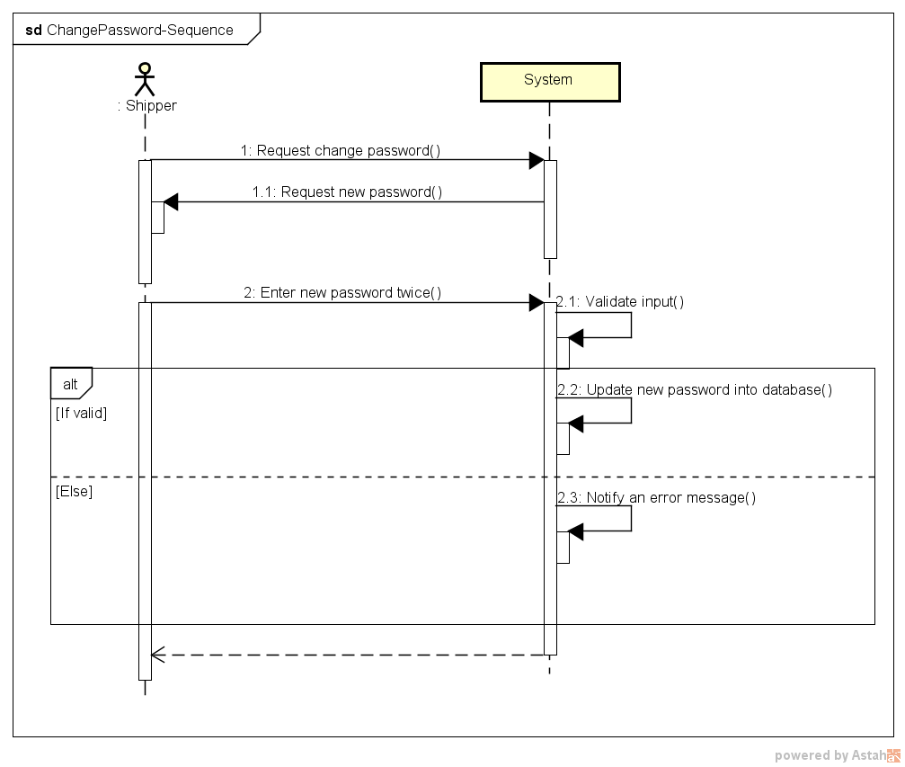

|  |  |  |  |  |
| --- | --- | --- | --- | --- |
| Use Case ID: | | UC-304 | | |
| Use Case Name: | | Change password | | |
| Created By: | | QuyenNV | Last Updated By: | QuyenNV |
| Date Created: | | 19/09/2015 | Date Last Updated: | 25/09/2015 |
| Actor: | | Shipper | | |
| Description: | | Shipper wants change their password. | | |
| Triggering event | | Shipper changes password. | | |
| Preconditions: | | * To have internet connection through device * To be logged in the system * Switch to “Profile” screen | | |
| Post - conditions: | | * New password stored in database. Shipper changes password is successfully | | |
| Priority: | | High | | |
| Frequency of Use: | | Sometime | | |
| **Main flow** | | | | |
| Step | Actor | Action | | |
|  | Shipper | Click “Change Password” button | | |
|  | System | “Change Password” screen shows up. | | |
|  | Shipper | Enter required information (Old Password, new password, re-enter password) and click “Update Password” button. | | |
|  | System | Validate input | | |
|  | System | Update new password of this account to database and redirect to the “Profile” screen. | | |
| **Alternative Flows:** | | N/A | | |
| **Exceptions:** | | | | |
| EC1 | At step 4, if any field is incorrect format or blank | | | |
| Step | Actor | Action | | |
| 4.1 | System | Notify in screen with error message | | |
| EC2 | At step 4, if shipper provides new password doesn’t match the re-enter password | | | |
| Step | Actor | Action | | |
| 4.1 | System | Notify in screen with error message | | |
| **Includes:** | | N/A | | |
| **Special Requirements:** | | **Old Password:** Cannot be null.  **New Password:** Minimum of password is 7 character and needs at least one number.  **Re-Enter Password**: Cannot be null. | | |
| **Notes and Issues:** | | N/A | | |

###### *UC-305:* *View Profile*

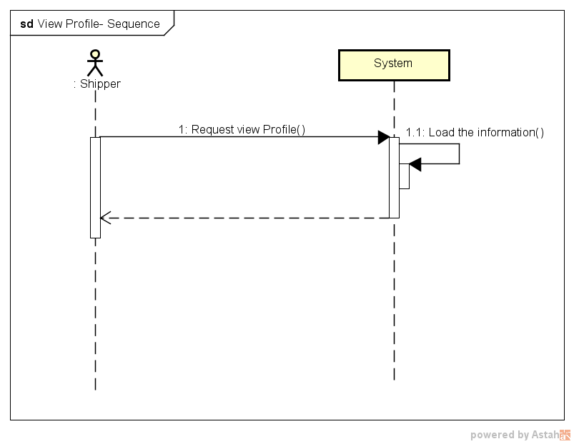

|  |  |  |  |  |
| --- | --- | --- | --- | --- |
| **Use Case ID:** | | UC-005 | | |
| **Use Case Name:** | | View Profile | | |
| **Created By:** | | QuyenNV | **Last Updated By:** | QuyenNV |
| **Date Created:** | | 19/09/2015 | **Date Last updated:** | 25/09/2015 |
| **Actor:** | | Shipper | | |
| **Description:** | | Shipper can view his/her information. | | |
| **Triggering event** | | Shipper wants view Profile | | |
| **Preconditions:** | | * To have internet connection through device * To be logged in the system | | |
| **Post conditions:** | | The information of current logged in will appear in the [Profile] screen. | | |
| **Priority:** | | High | | |
| **Frequency of Use:** | | Sometime | | |
| **Main flow** | | | | |
| Step | Actor | Action | | |
| 1 | Shipper | Click “Profile” button in left navigate bar | | |
| 2 | System | Load information of shipper and Display “Profile” screen | | |
| **Alternative Flows:** | | **N/A** | | |
| **Exceptions:** | | | | |
| **Includes:** | | N/A | | |
| **Special Requirements:** | | N/A | | |
| **Notes and Issues:** | | N/A | | |

###### *UC-306:* *Update Profile*

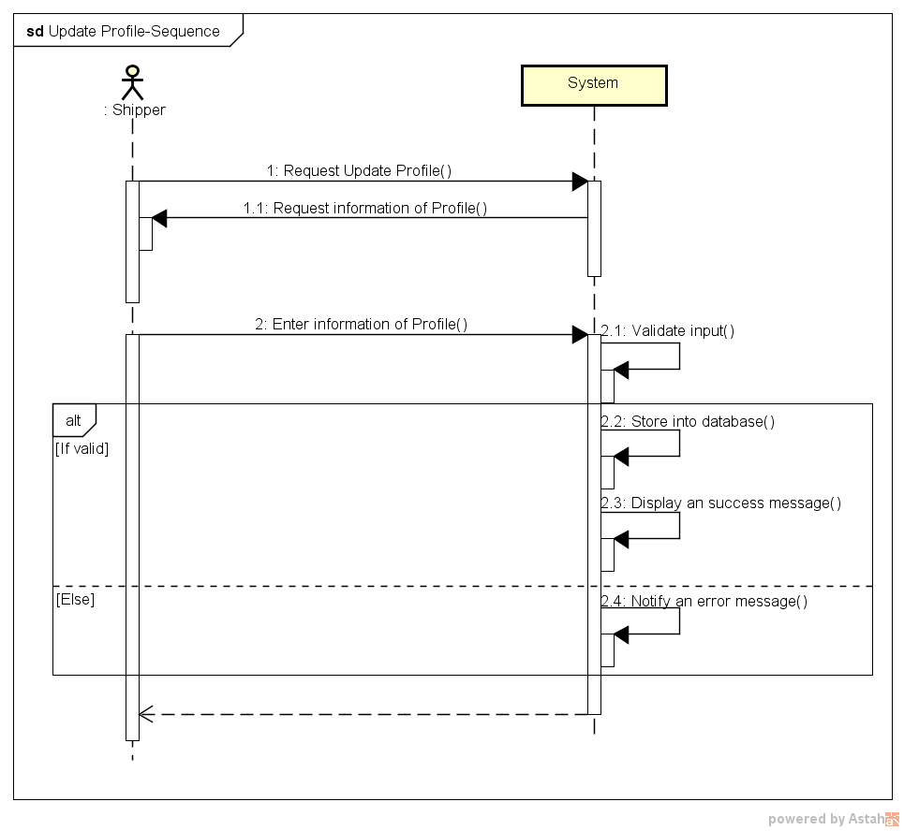

|  |  |  |  |  |
| --- | --- | --- | --- | --- |
| **Use Case ID:** | | UC-006 | | |
| **Use Case Name:** | | Update Profile | | |
| **Created By:** | | QuyenNV | **Last Updated By:** | QuyenNV |
| **Date Created:** | | 19/09/2015 | **Date Last updated:** | 25/09/2015 |
| **Actor:** | | Shipper | | |
| **Description:** | | Shipper can modify their related information (Email, Date of Birth, Phone Number, Identity Card, Address) | | |
| **Triggering event** | | Shipper wants to update their profile | | |
| **Preconditions:** | | * To have internet connection through device * To be logged in the system * Switch to [Profile] screen. | | |
| **Post conditions:** | | Update new information in database. Update Profile is successfully. | | |
| **Priority:** | | Low | | |
| **Frequency of Use:** | | Sometime | | |
| **Main flow** | | | | |
| Step | Actor | Action | | |
| 1 | Shipper | Click [Edit Profile] button | | |
| 2 | System | Display [Edit profile] screen | | |
| 3 | Shipper | Enter required information (Name, Email, Phone Number, Identity Card, Date of Birth, Address) | | |
| 5 | System | Validate input | | |
| 6 | System | Store new information of Shipper into database | | |
| 7 | System | Display an success message to shipper | | |
| **Alternative Flows:** | | **N/A** | | |
| **Exceptions:** | | | | |
| EC1 | At step 5 | If any required field is not entered | | |
| Step | Actor | Action | | |
| 5.1 | System | Notify an error message “*is require” | | |
| **Includes:** | | N/A | | |
| **Special Requirements:** | | N/A | | |
| **Notes and Issues:** | | N/A | | |

###### *UC-307:* *Confirm Code*

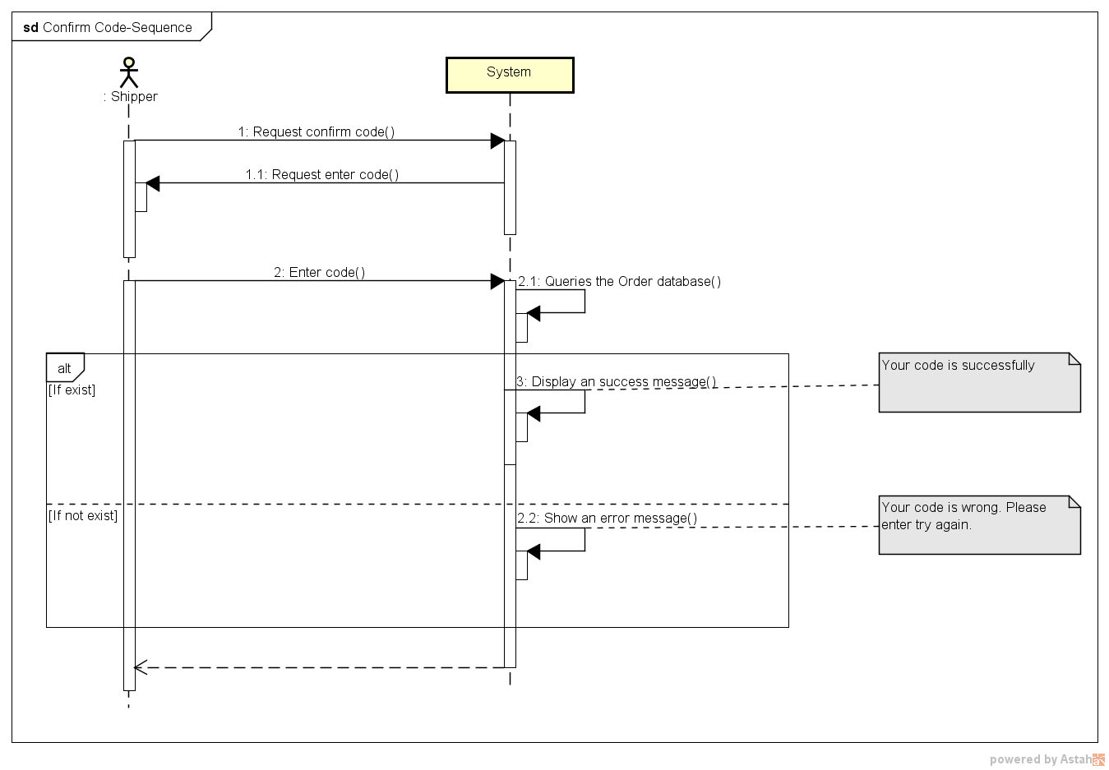

|  |  |  |  |  |
| --- | --- | --- | --- | --- |
| **Use Case ID:** | | UC-007 | | |
| **Use Case Name:** | | Confirm Code | | |
| **Created By:** | | QuyenNV | **Last Updated By:** | QuyenNV |
| **Date Created:** | | 19/09/2015 | **Date Last updated:** | 25/09/2015 |
| **Actor:** | | Shipper | | |
| **Description:** | | Shipper entered code to confirm with customer. If code is wrong, shipper don’t pick up order from customer. Code is automatically generated by system. | | |
| **Triggering event** | | Shipper confirm code which automatically generated by system. | | |
| **Preconditions:** | | * To have internet connection through device * To be logged in the system * Switch to [View Order’s Details] screen. | | |
| **Post conditions:** | | Order’s Code is confirmed | | |
| **Priority:** | | High | | |
| **Frequency of Use:** | | Always | | |
| **Main flow** | | | | |
| Step | Actor | Action | | |
| 1. | Shipper | Click [Enter Code] button | | |
| 2. | System | Display [Enter Code] | | |
| 3. | Shipper | Enter code which be provided by customer and click “Enter” button. | | |
| 4. | System | Queries the Order database | | |
| 5. | System | Display an success message on [View Order’s Details] screen | | |
| **Alternative Flows:** | | **N/A** | | |
| **Exceptions:** | | | | |
| EC1 | At step 4, if code in Order database does not exist or Order cannot establish a connection to the database due to some reasons (ex: network failure). | | | |
| Step | Actor | Action | | |
| 4.1 | System | An error message will show up on screen to tell the shipper about the problem | | |
| **Includes:** | | N/A | | |
| **Special Requirements:** | | N/A | | |
| **Notes and Issues:** | | N/A | | |